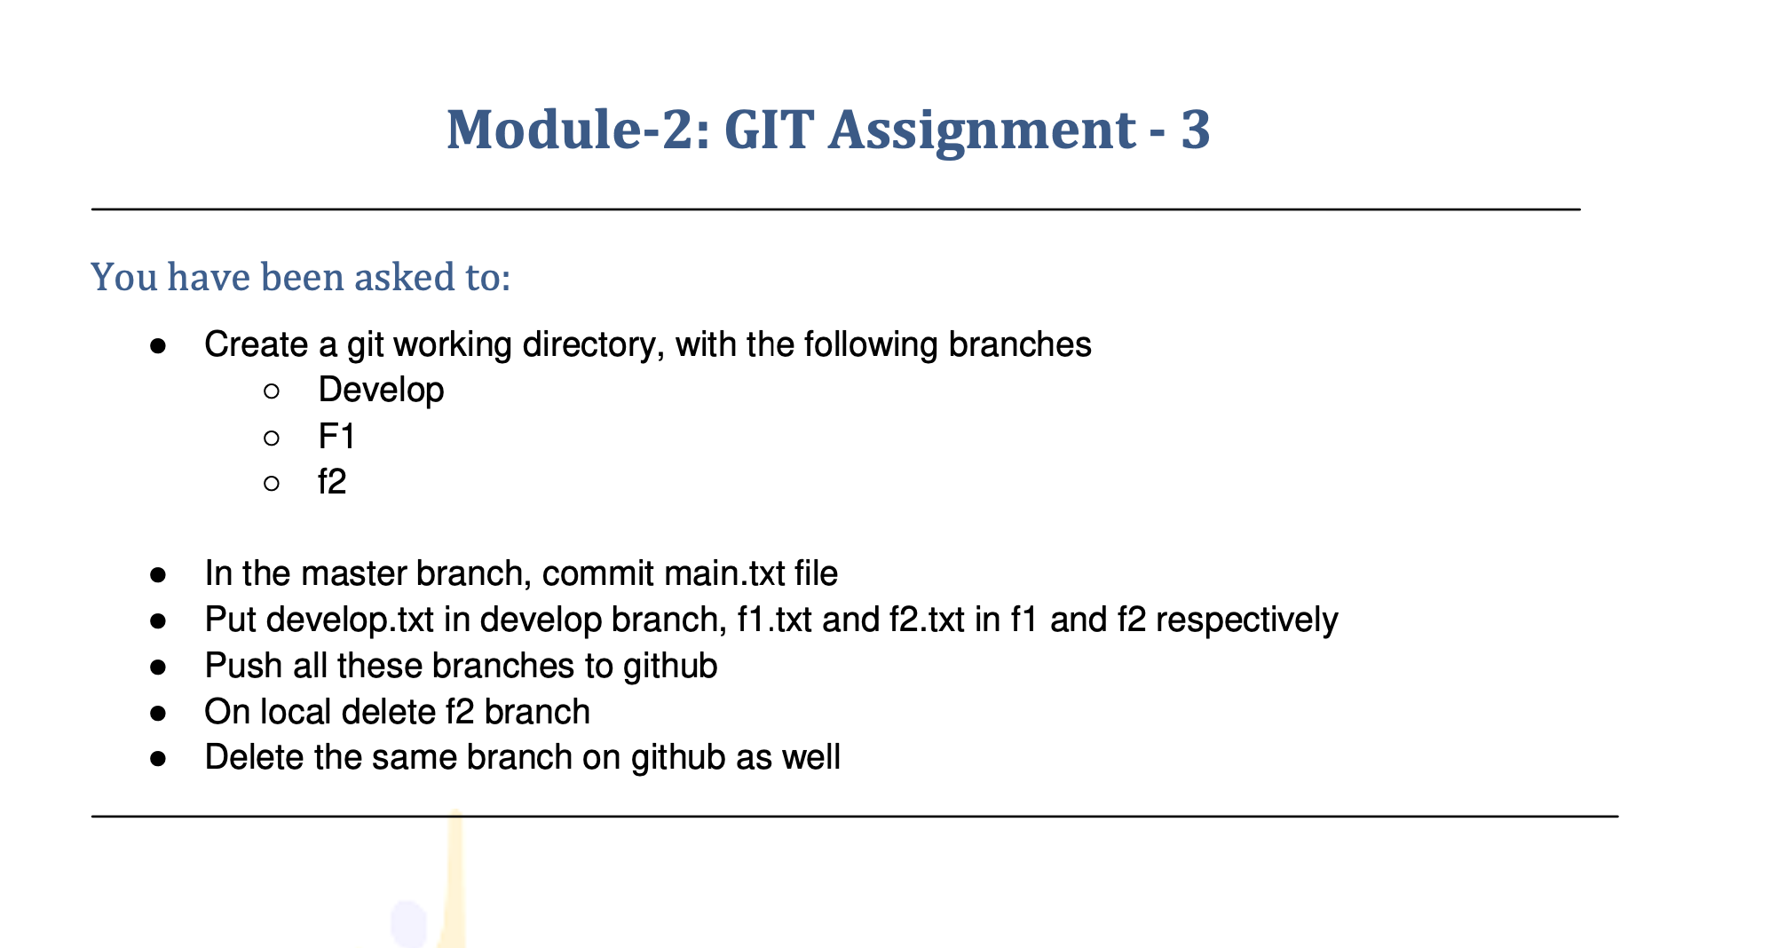

You have been asked to:

* ●  Create a git working directory, with the following branches ○ Develop

○ F1 ○ f2

* ●  In the master branch, commit main.txt file
* ●  Put develop.txt in develop branch, f1.txt and f2.txt in f1 and f2 respectively
* ●  Push all these branches to github
* ●  On local delete f2 branch
* ●  Delete the same branch on github as well

First complte the 2nd question and then complete the 1st question its tricky question .

First create the main.txt file in master branch and branched we need to create

* In the master branch, commit main.txt file

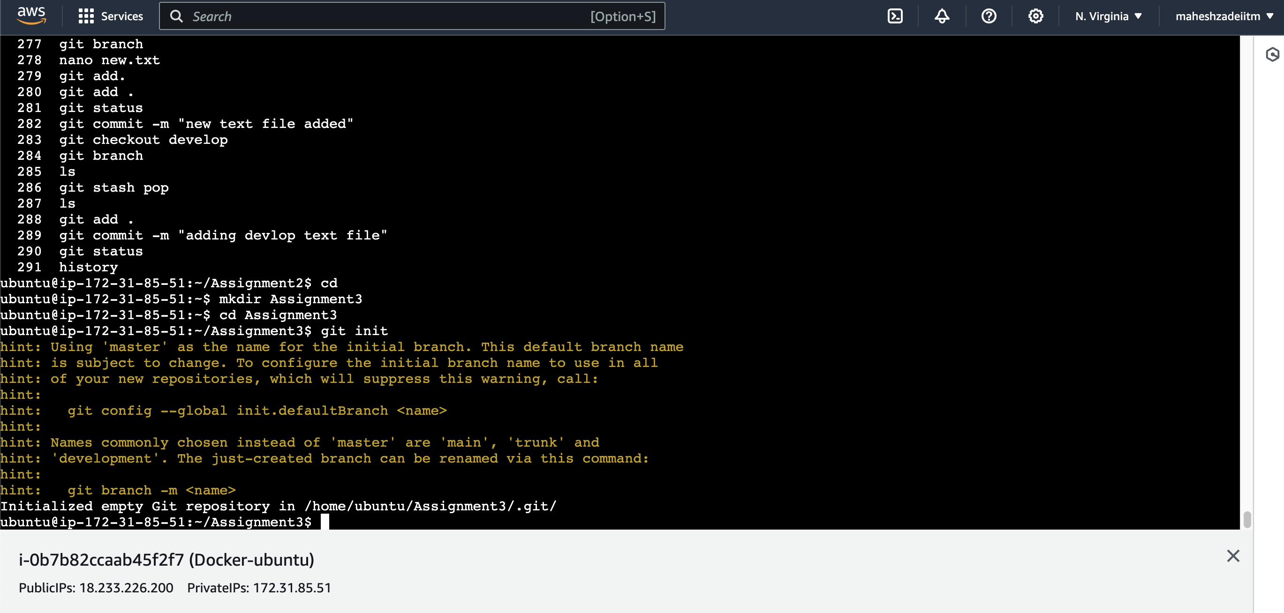

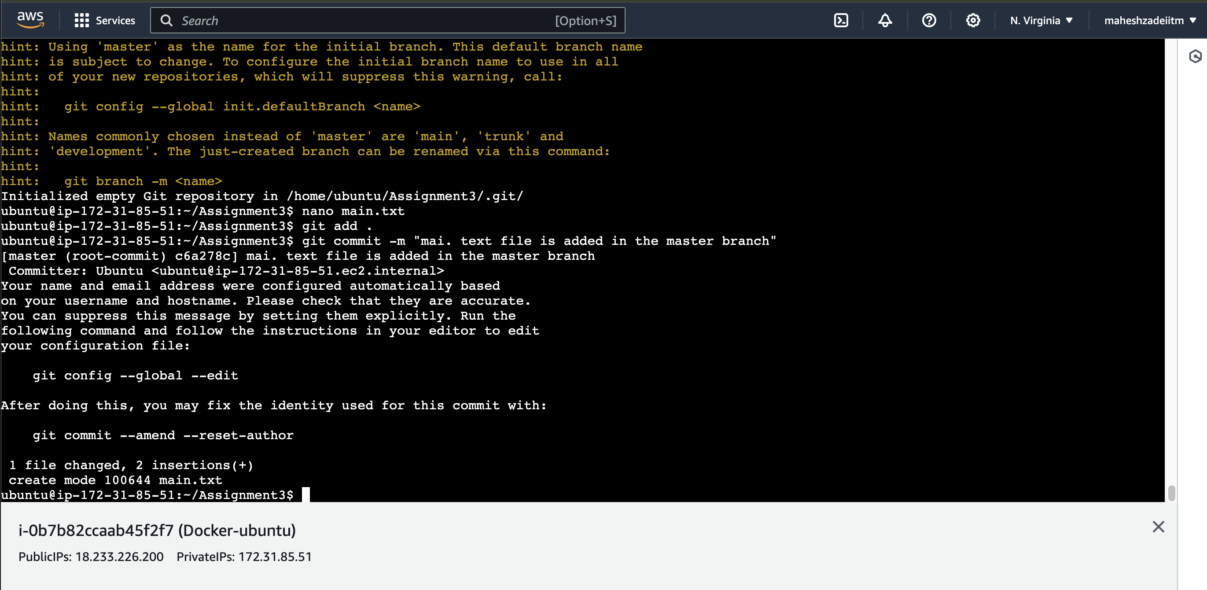

Now check the branch

ubuntu@ip-172-31-85-51:~/Assignment3$ git branch

* master

ubuntu@ip-172-31-85-51:~/Assignment3$

now create the 3 branches as per the first question

* Create a git working directory, with the following branches
* ○ Develop
* ○ F1
* ○ f2

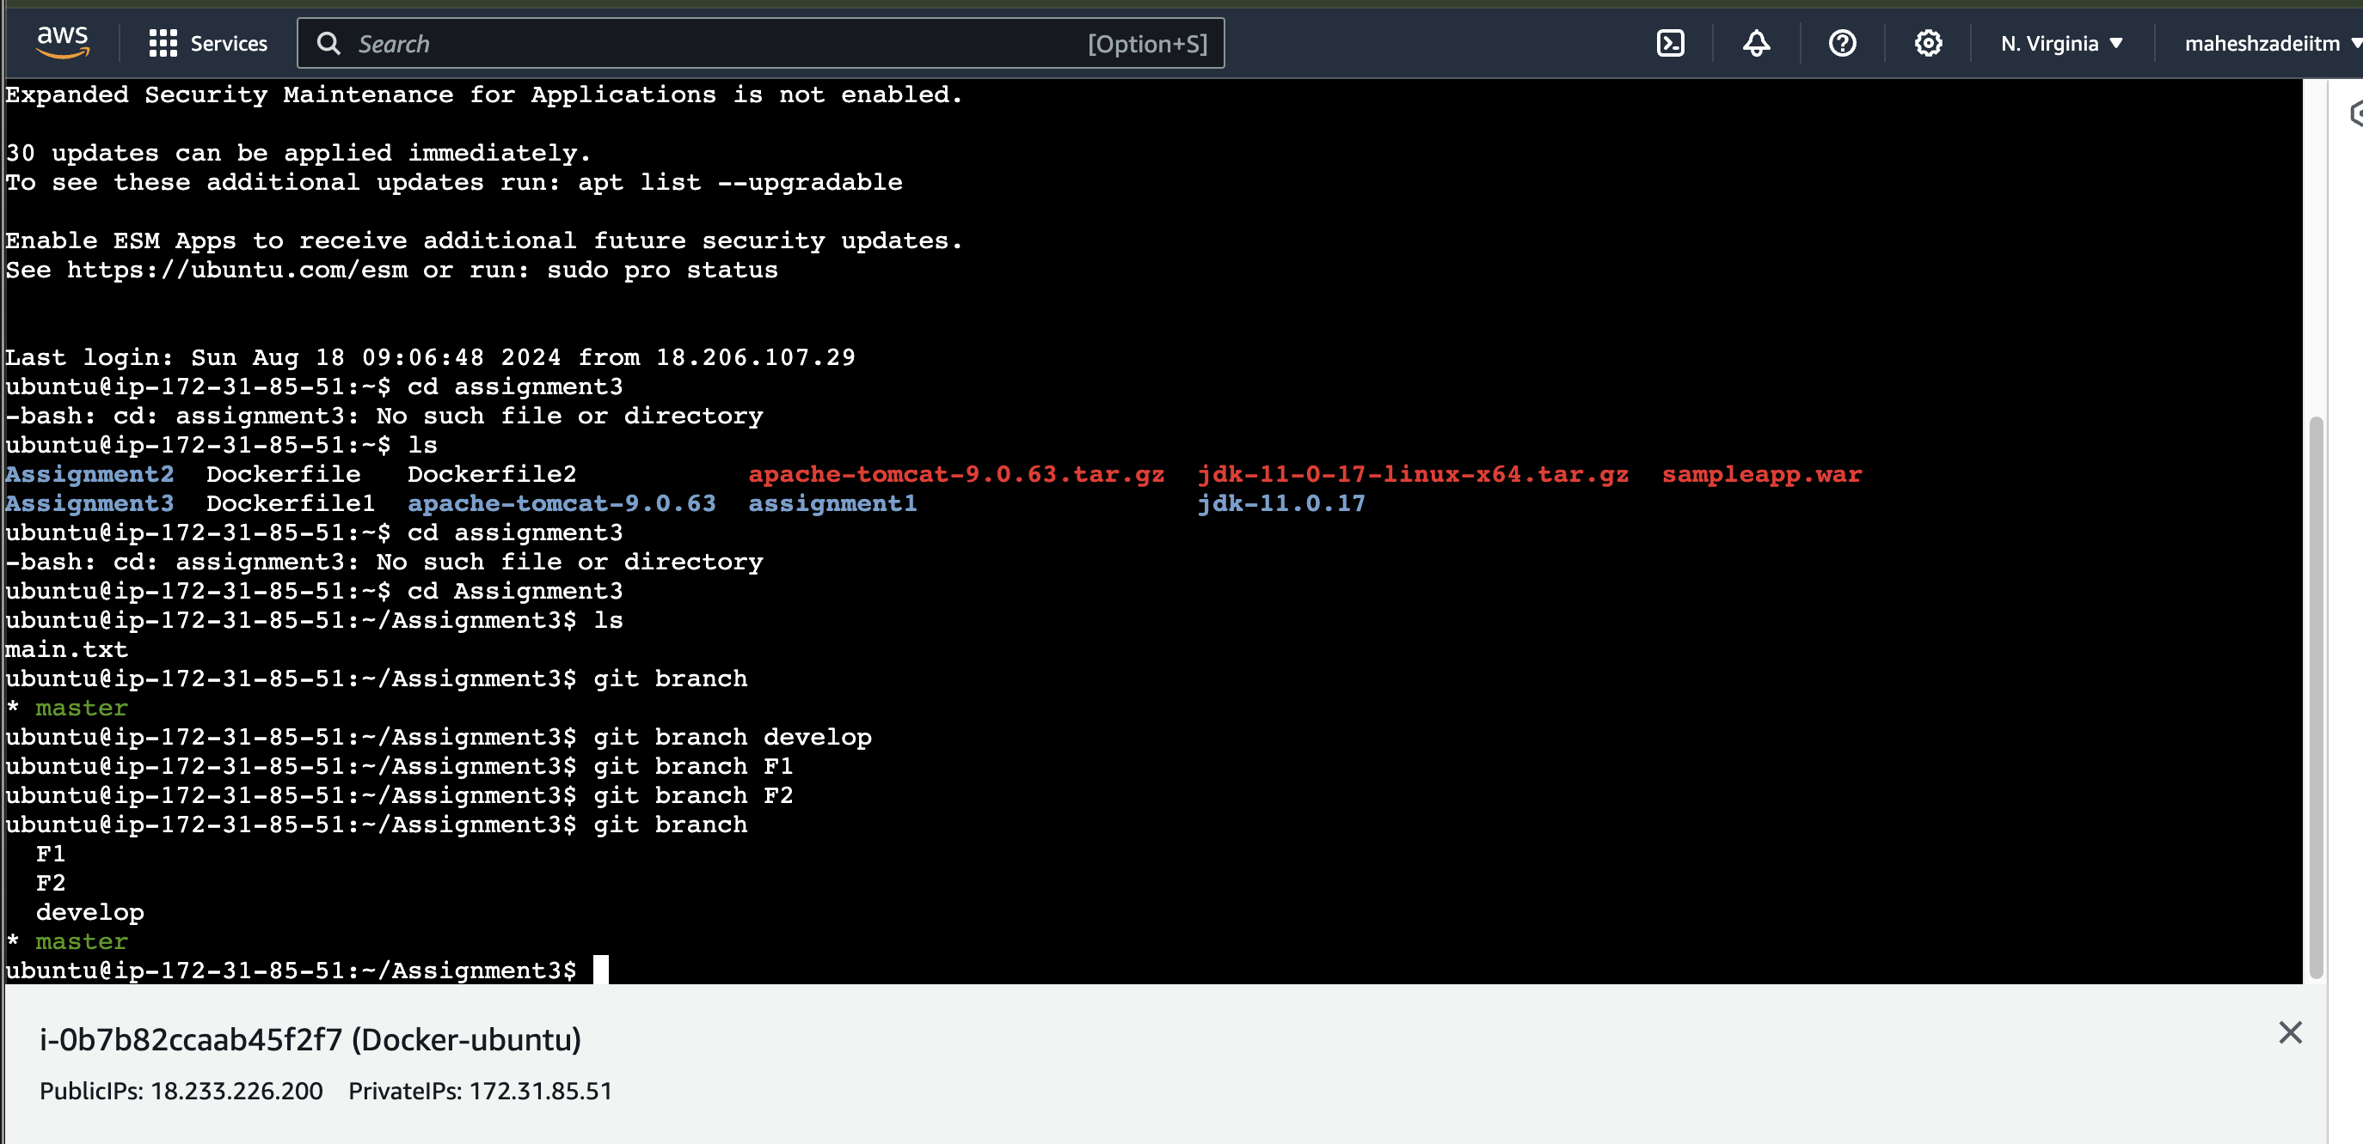

* Put develop.txt in develop branch, f1.txt and f2.txt in f1 and f2 respectively

ubuntu@ip-172-31-85-51:~/Assignment3$ git checkout develop

Switched to branch 'develop'

ubuntu@ip-172-31-85-51:~/Assignment3$ git branch

F1

F2

* develop

Master

Now create the develop.txt file in Develop branch

ubuntu@ip-172-31-85-51:~/Assignment3$ touch develop.txt

ubuntu@ip-172-31-85-51:~/Assignment3$ ls

develop.txt main.txt

ubuntu@ip-172-31-85-51:~/Assignment3$

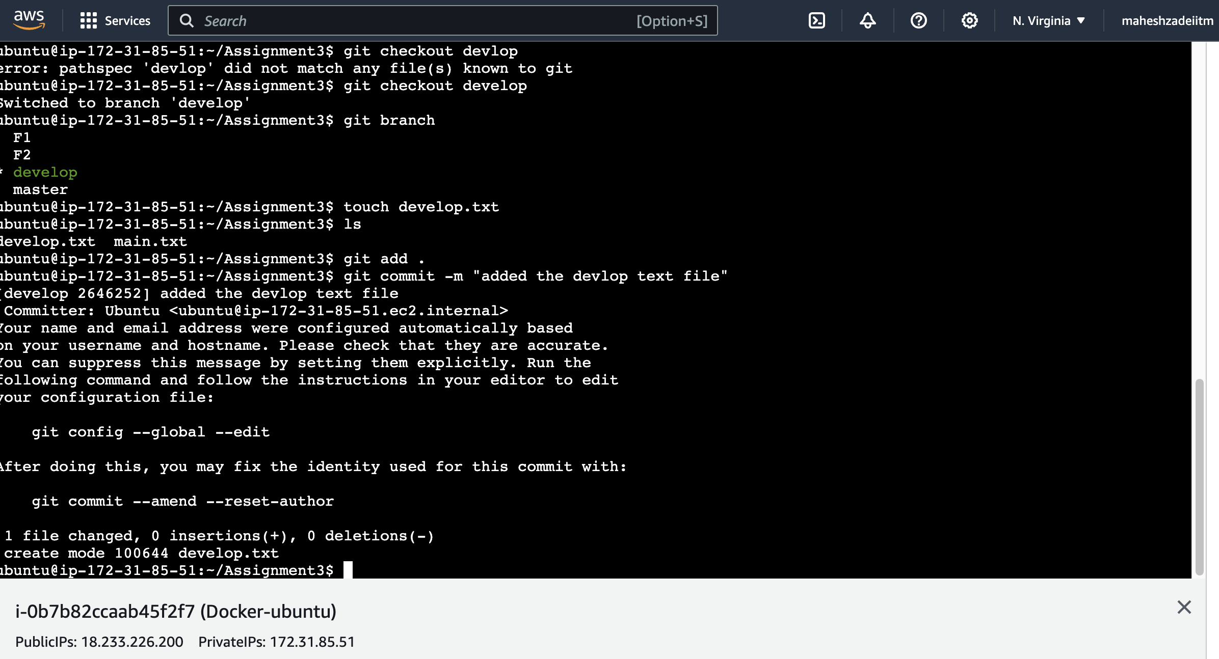

I am in git branch

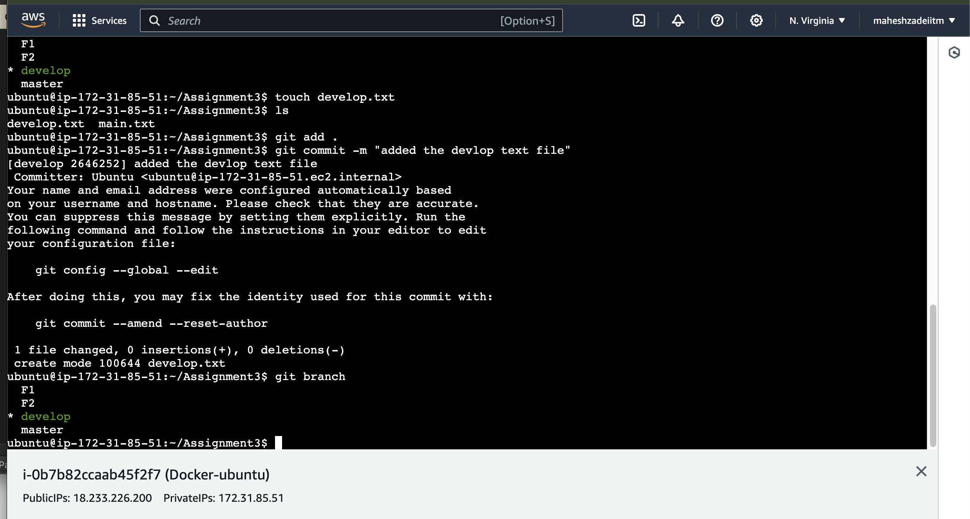

ubuntu@ip-172-31-85-51:~/Assignment3$ git status

On branch develop

nothing to commit, working tree clean

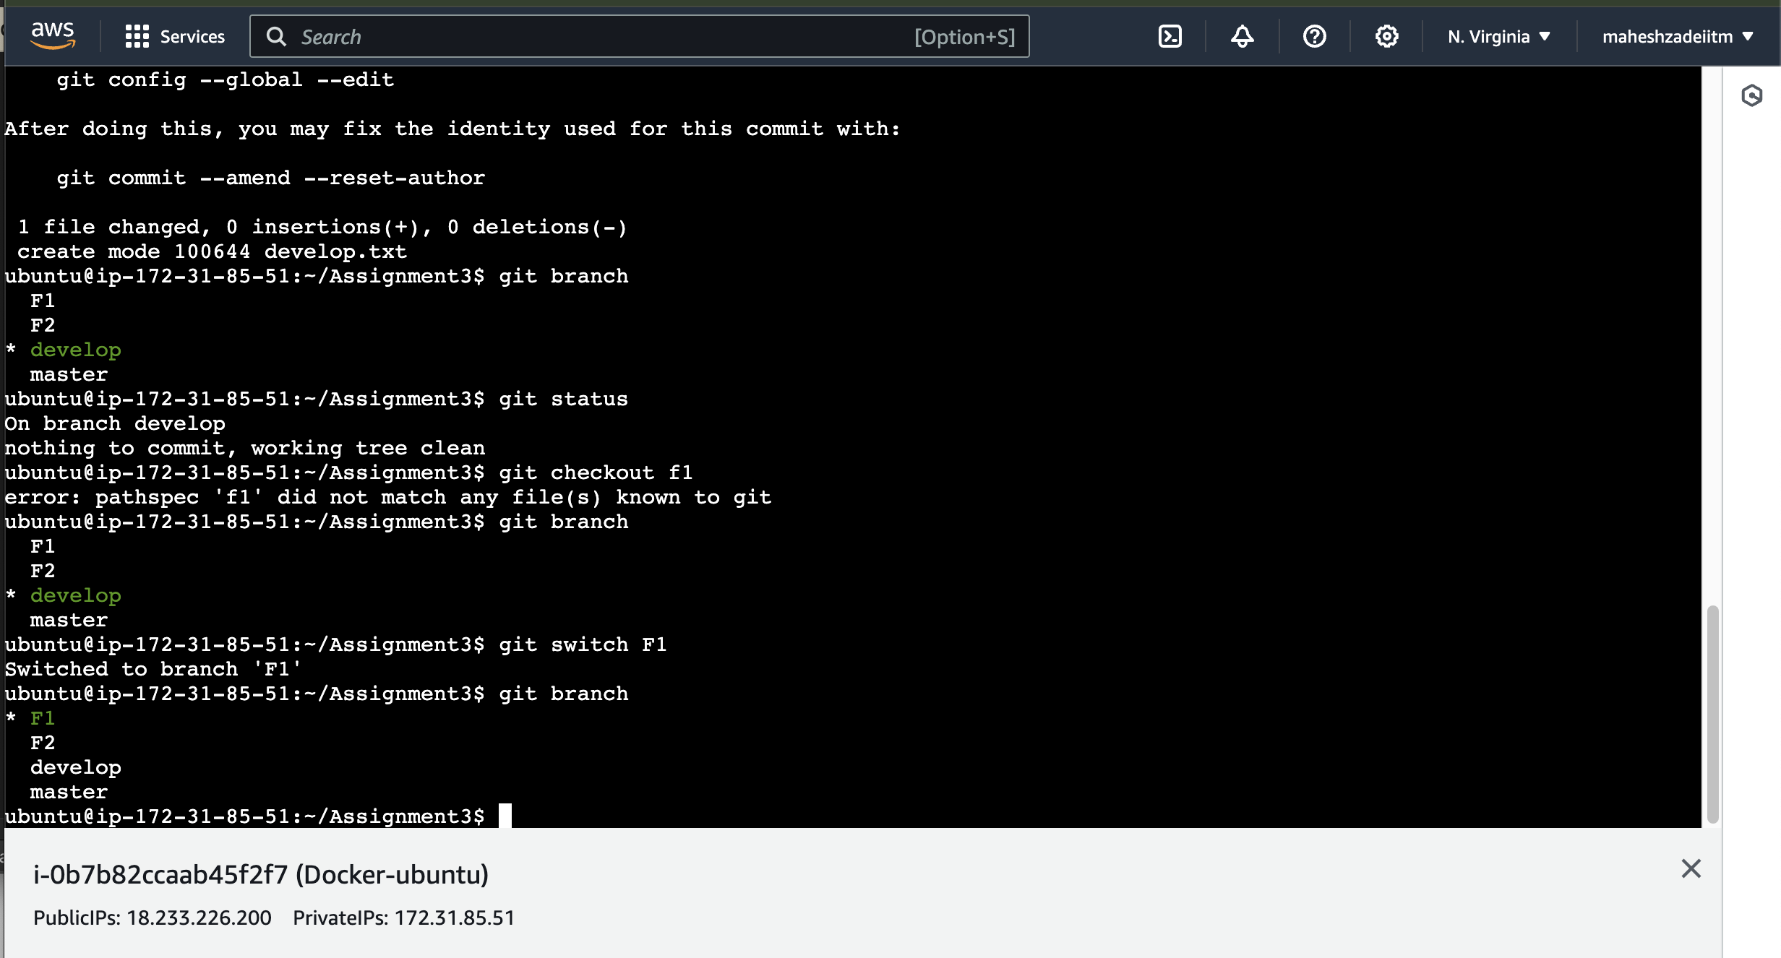

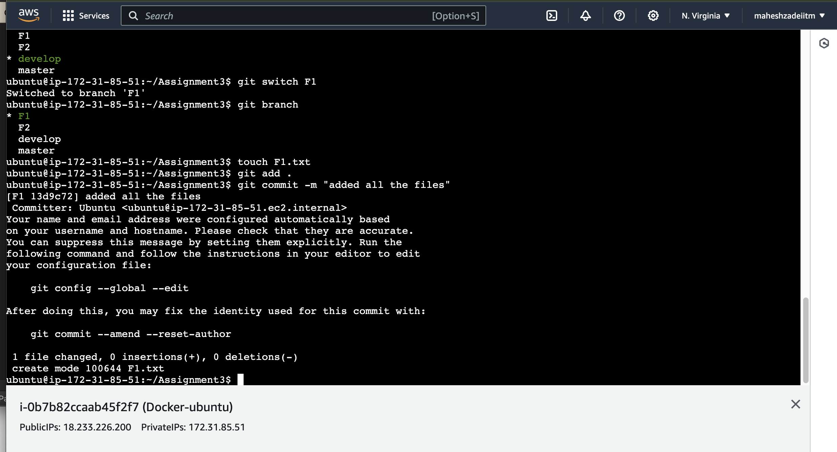

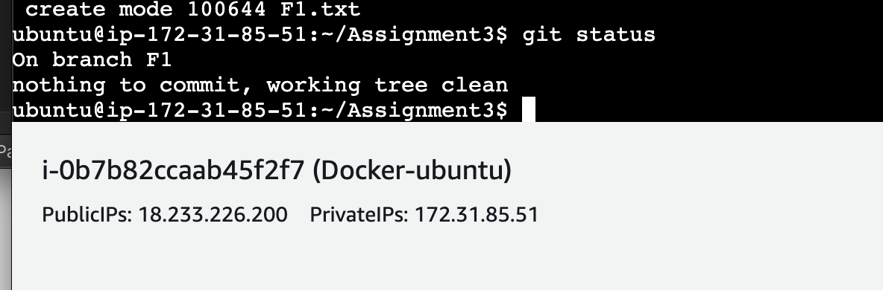

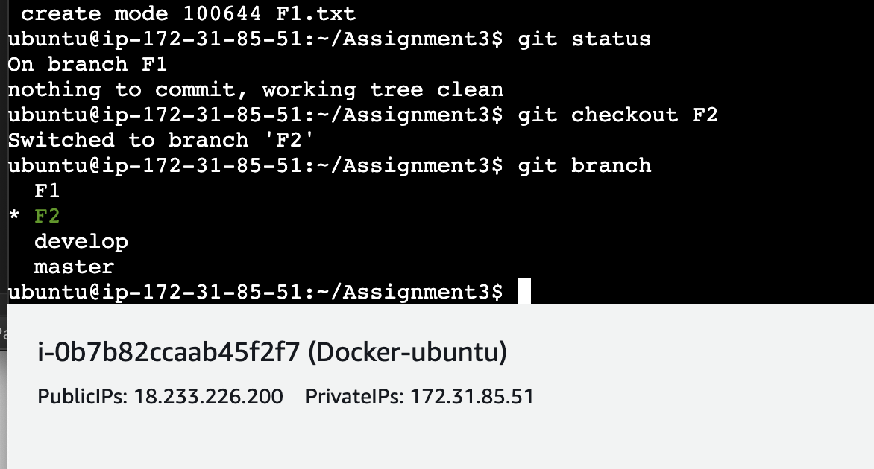

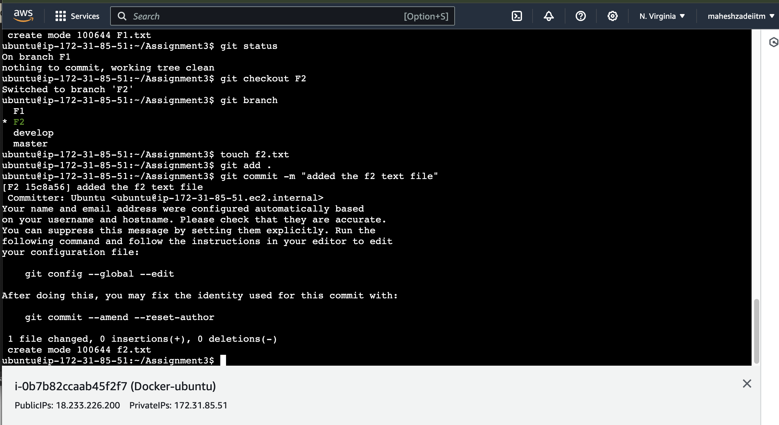

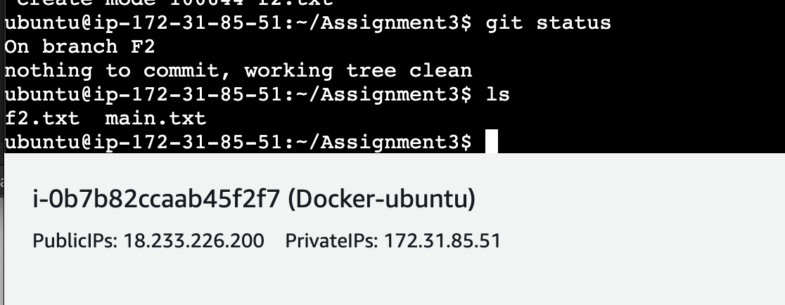



**Go back to home directory in EC2 Machine**

* Push all these branches to github

**For that go to home directory in EC2 Machine**

**ubuntu@ip-172-31-85-51:~/Assignment3$ ssh-keygen**

**Generating public/private ed25519 key pair.**

**Enter file in which to save the key (/home/ubuntu/.ssh/id_ed25519):**

**Press enter , enter ,enter**

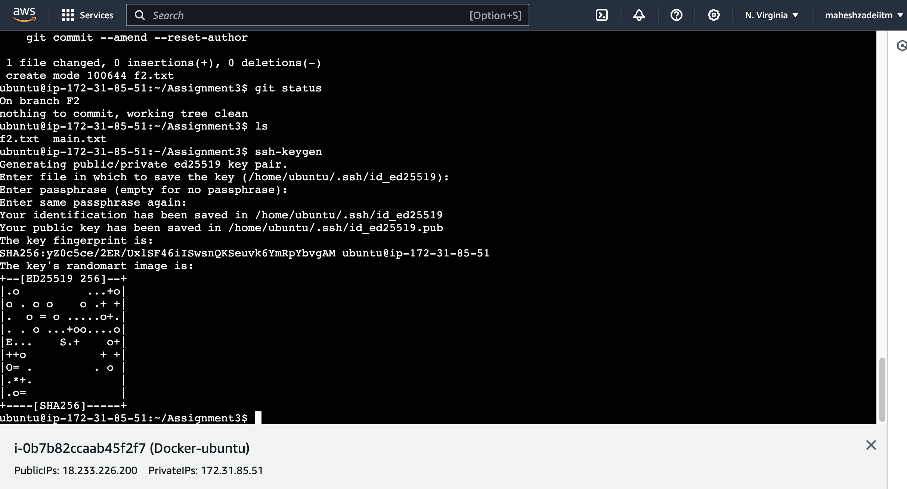

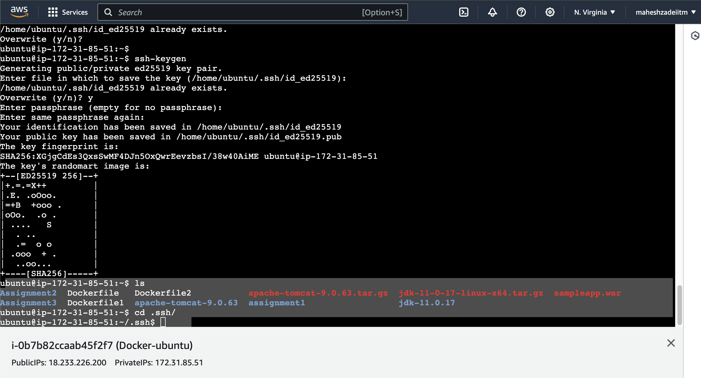

**Ls**

**ubuntu@ip-172-31-85-51:~/.ssh$ ls**

[**ubuntu@ip-172-31-85-51:~/.ssh$**](mailto:ubuntu@ip-172-31-85-51:~/.ssh$)

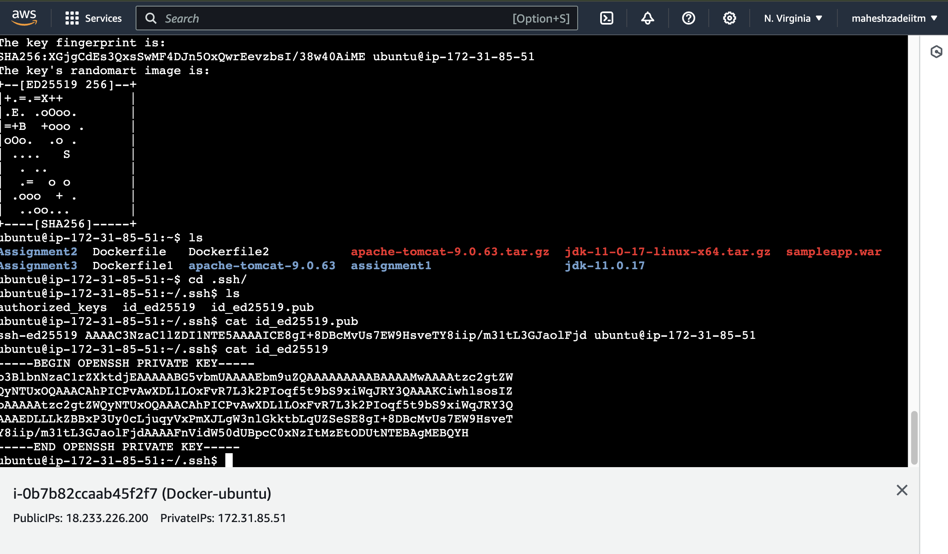

**Copy the key**

**ssh-ed25519 AAAAC3NzaC1lZDI1NTE5AAAAICE8gI+8DBcMvUs7EW9HsveTY8iip/m31tL3GJaolFjd ubuntu@ip-172-31-85-51**

**And paste in the github account –setting –ssh and gpg keys**

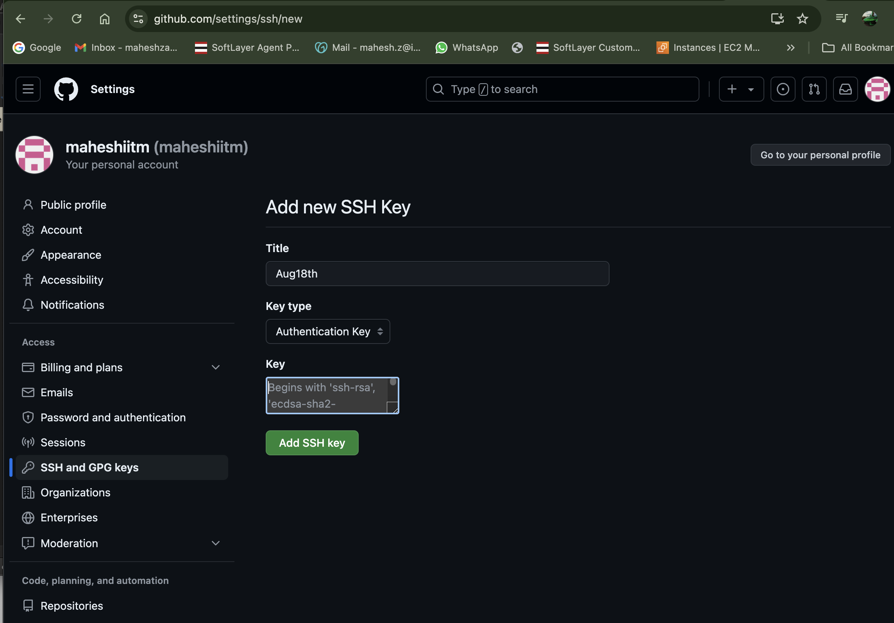

**Craeted new repository 18thaugassignment3**

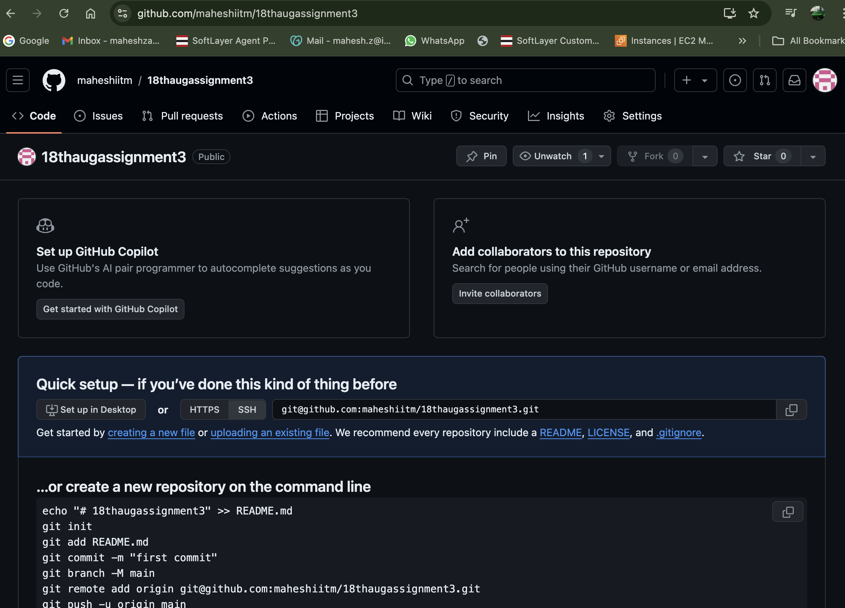

**Copy the ss hurl**



[**git@github.com:maheshiitm/18thaugassignment3.git**](mailto:git@github.com:maheshiitm/18thaugassignment3.git)

**go to EC2 Instance**

**update the sever by**

**sudo apt update**

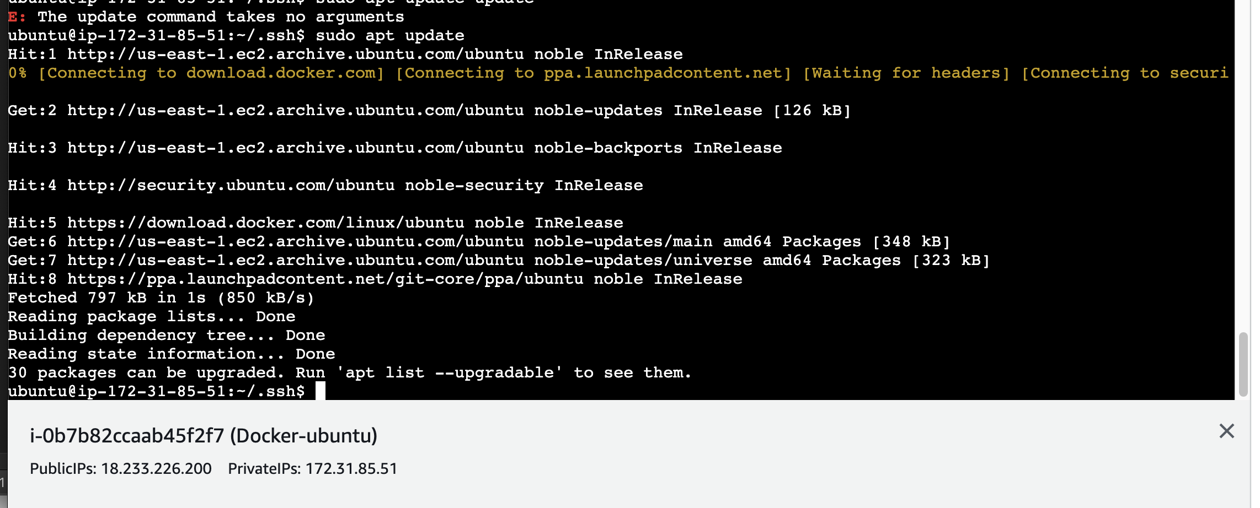

**Go back to assignment3 directory back**

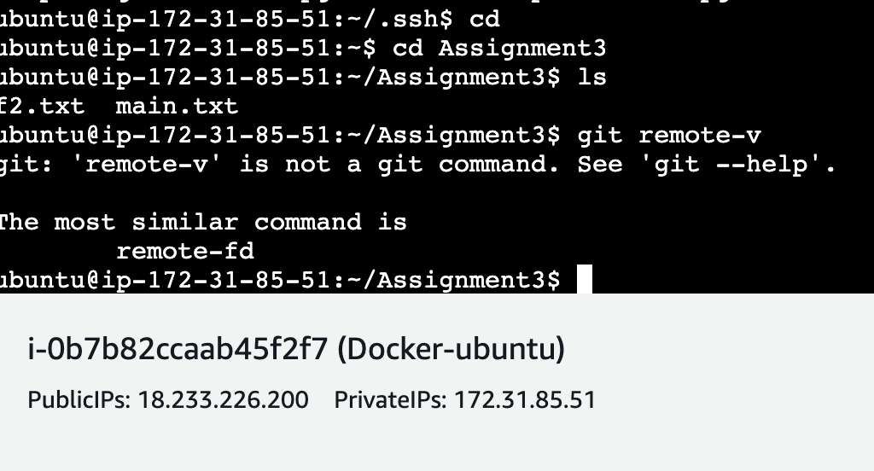

**Use the command**

**ubuntu@ip-172-31-85-51:~/Assignment3$ git remote add origin** [**git@github.com:maheshiitm/18thaugassignment3.git**](mailto:git@github.com:maheshiitm/18thaugassignment3.git)

**ubuntu@ip-172-31-85-51:~$ cd Assignment3**

**ubuntu@ip-172-31-85-51:~/Assignment3$ ls**

**f2.txt main.txt**

**ubuntu@ip-172-31-85-51:~/Assignment3$ git remote-v**

**git: 'remote-v' is not a git command. See 'git --help'.**

**The most similar command is**

**remote-fd**

**ubuntu@ip-172-31-85-51:~/Assignment3$ git remote add origin git@github.com:maheshiitm/18thaugassignment3.git**

**ubuntu@ip-172-31-85-51:~/Assignment3$ git push origin --all**

**The authenticity of host 'github.com (140.82.113.3)' can't be established.**

**ED25519 key fingerprint is SHA256:+DiY3wvvV6TuJJhbpZisF/zLDA0zPMSvHdkr4UvCOqU.**

**This key is not known by any other names.**

**Are you sure you want to continue connecting (yes/no/[fingerprint])? yes**

**Warning: Permanently added 'github.com' (ED25519) to the list of known hosts.**

**Enumerating objects: 10, done.**

**Counting objects: 100% (10/10), done.**

**Compressing objects: 100% (7/7), done.**

**Writing objects: 100% (10/10), 904 bytes | 904.00 KiB/s, done.**

**Total 10 (delta 2), reused 0 (delta 0), pack-reused 0 (from 0)**

**remote: Resolving deltas: 100% (2/2), done.**

**To github.com:maheshiitm/18thaugassignment3.git**

**\* [new branch] F1 -> F1**

**\* [new branch] F2 -> F2**

**\* [new branch] develop -> develop**

**\* [new branch] master -> master**

**ubuntu@ip-172-31-85-51:~/Assignment3$**

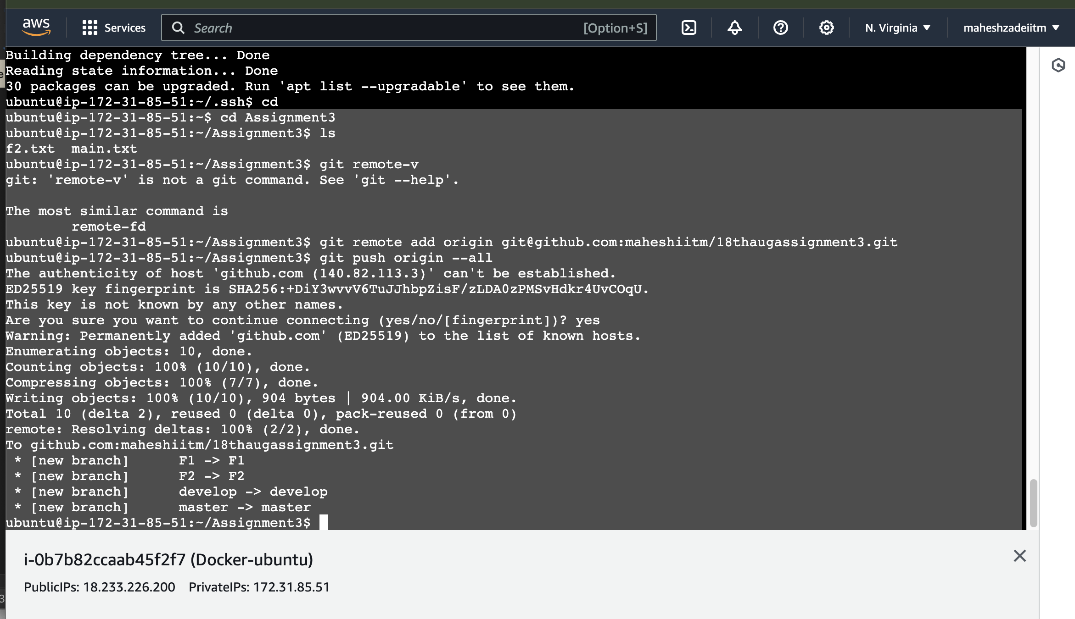

**It does not ask me for the github username and password for pushing all the branches from local to github account**

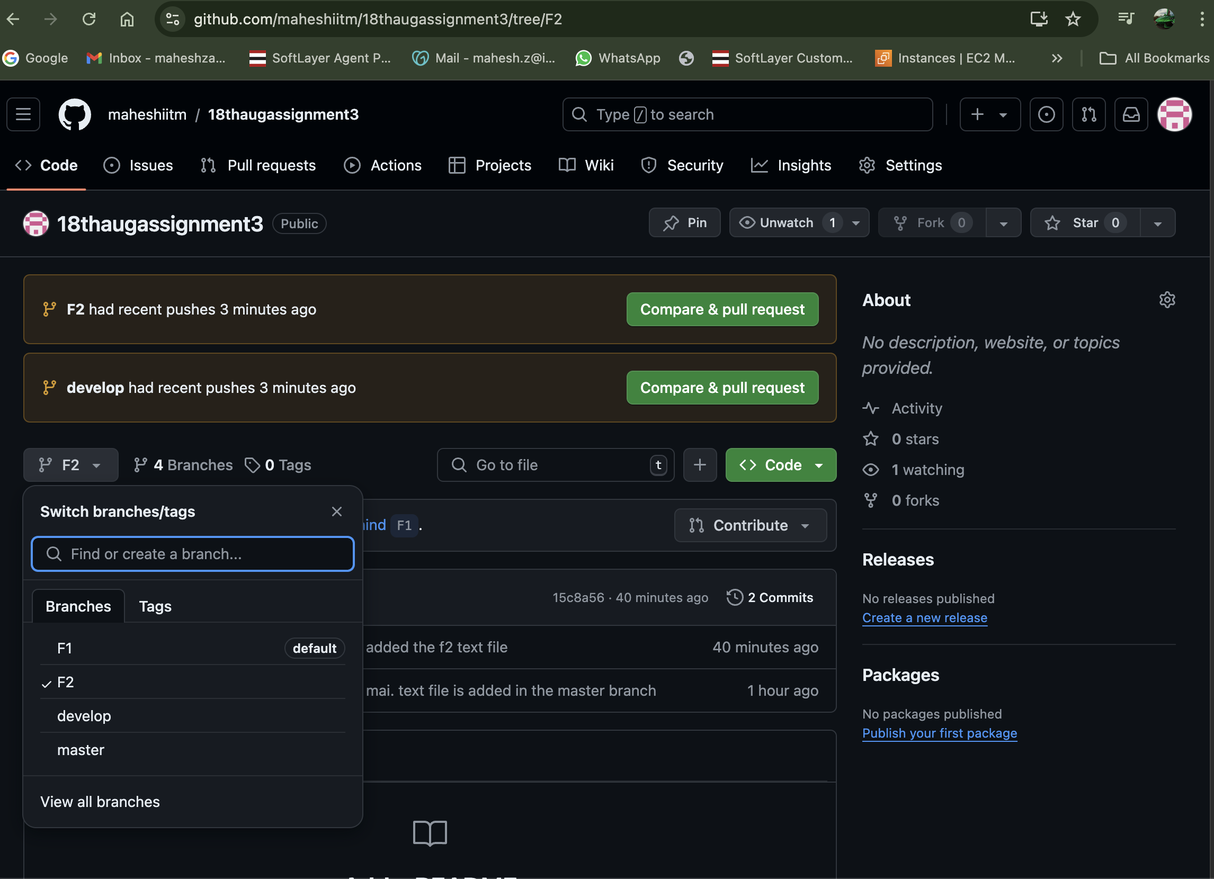

**Delete the F2 branch from local and github**

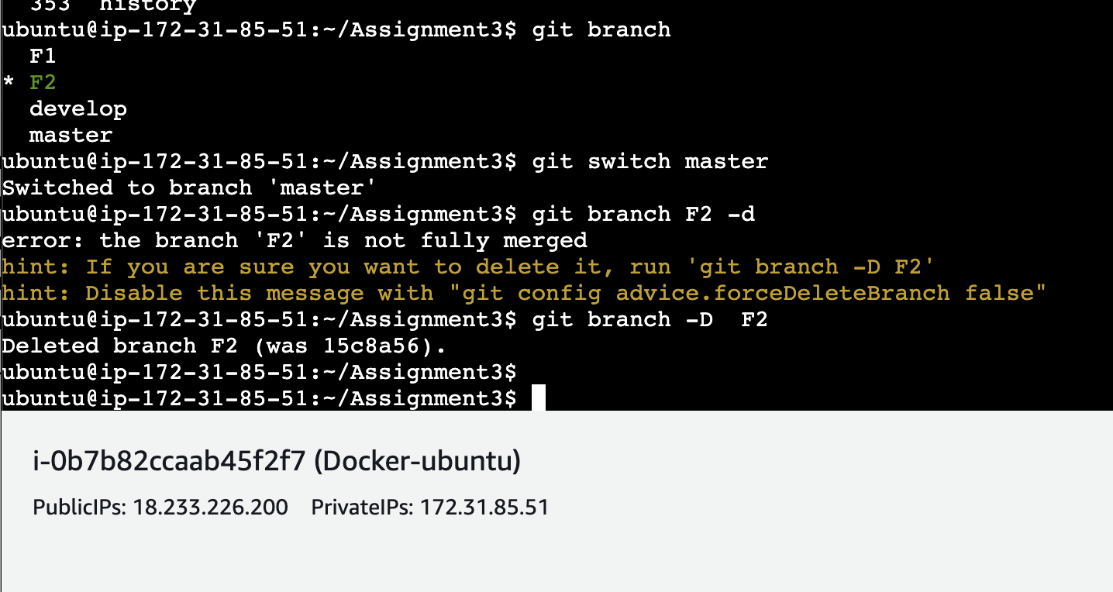

**Select the F2 branch in github**

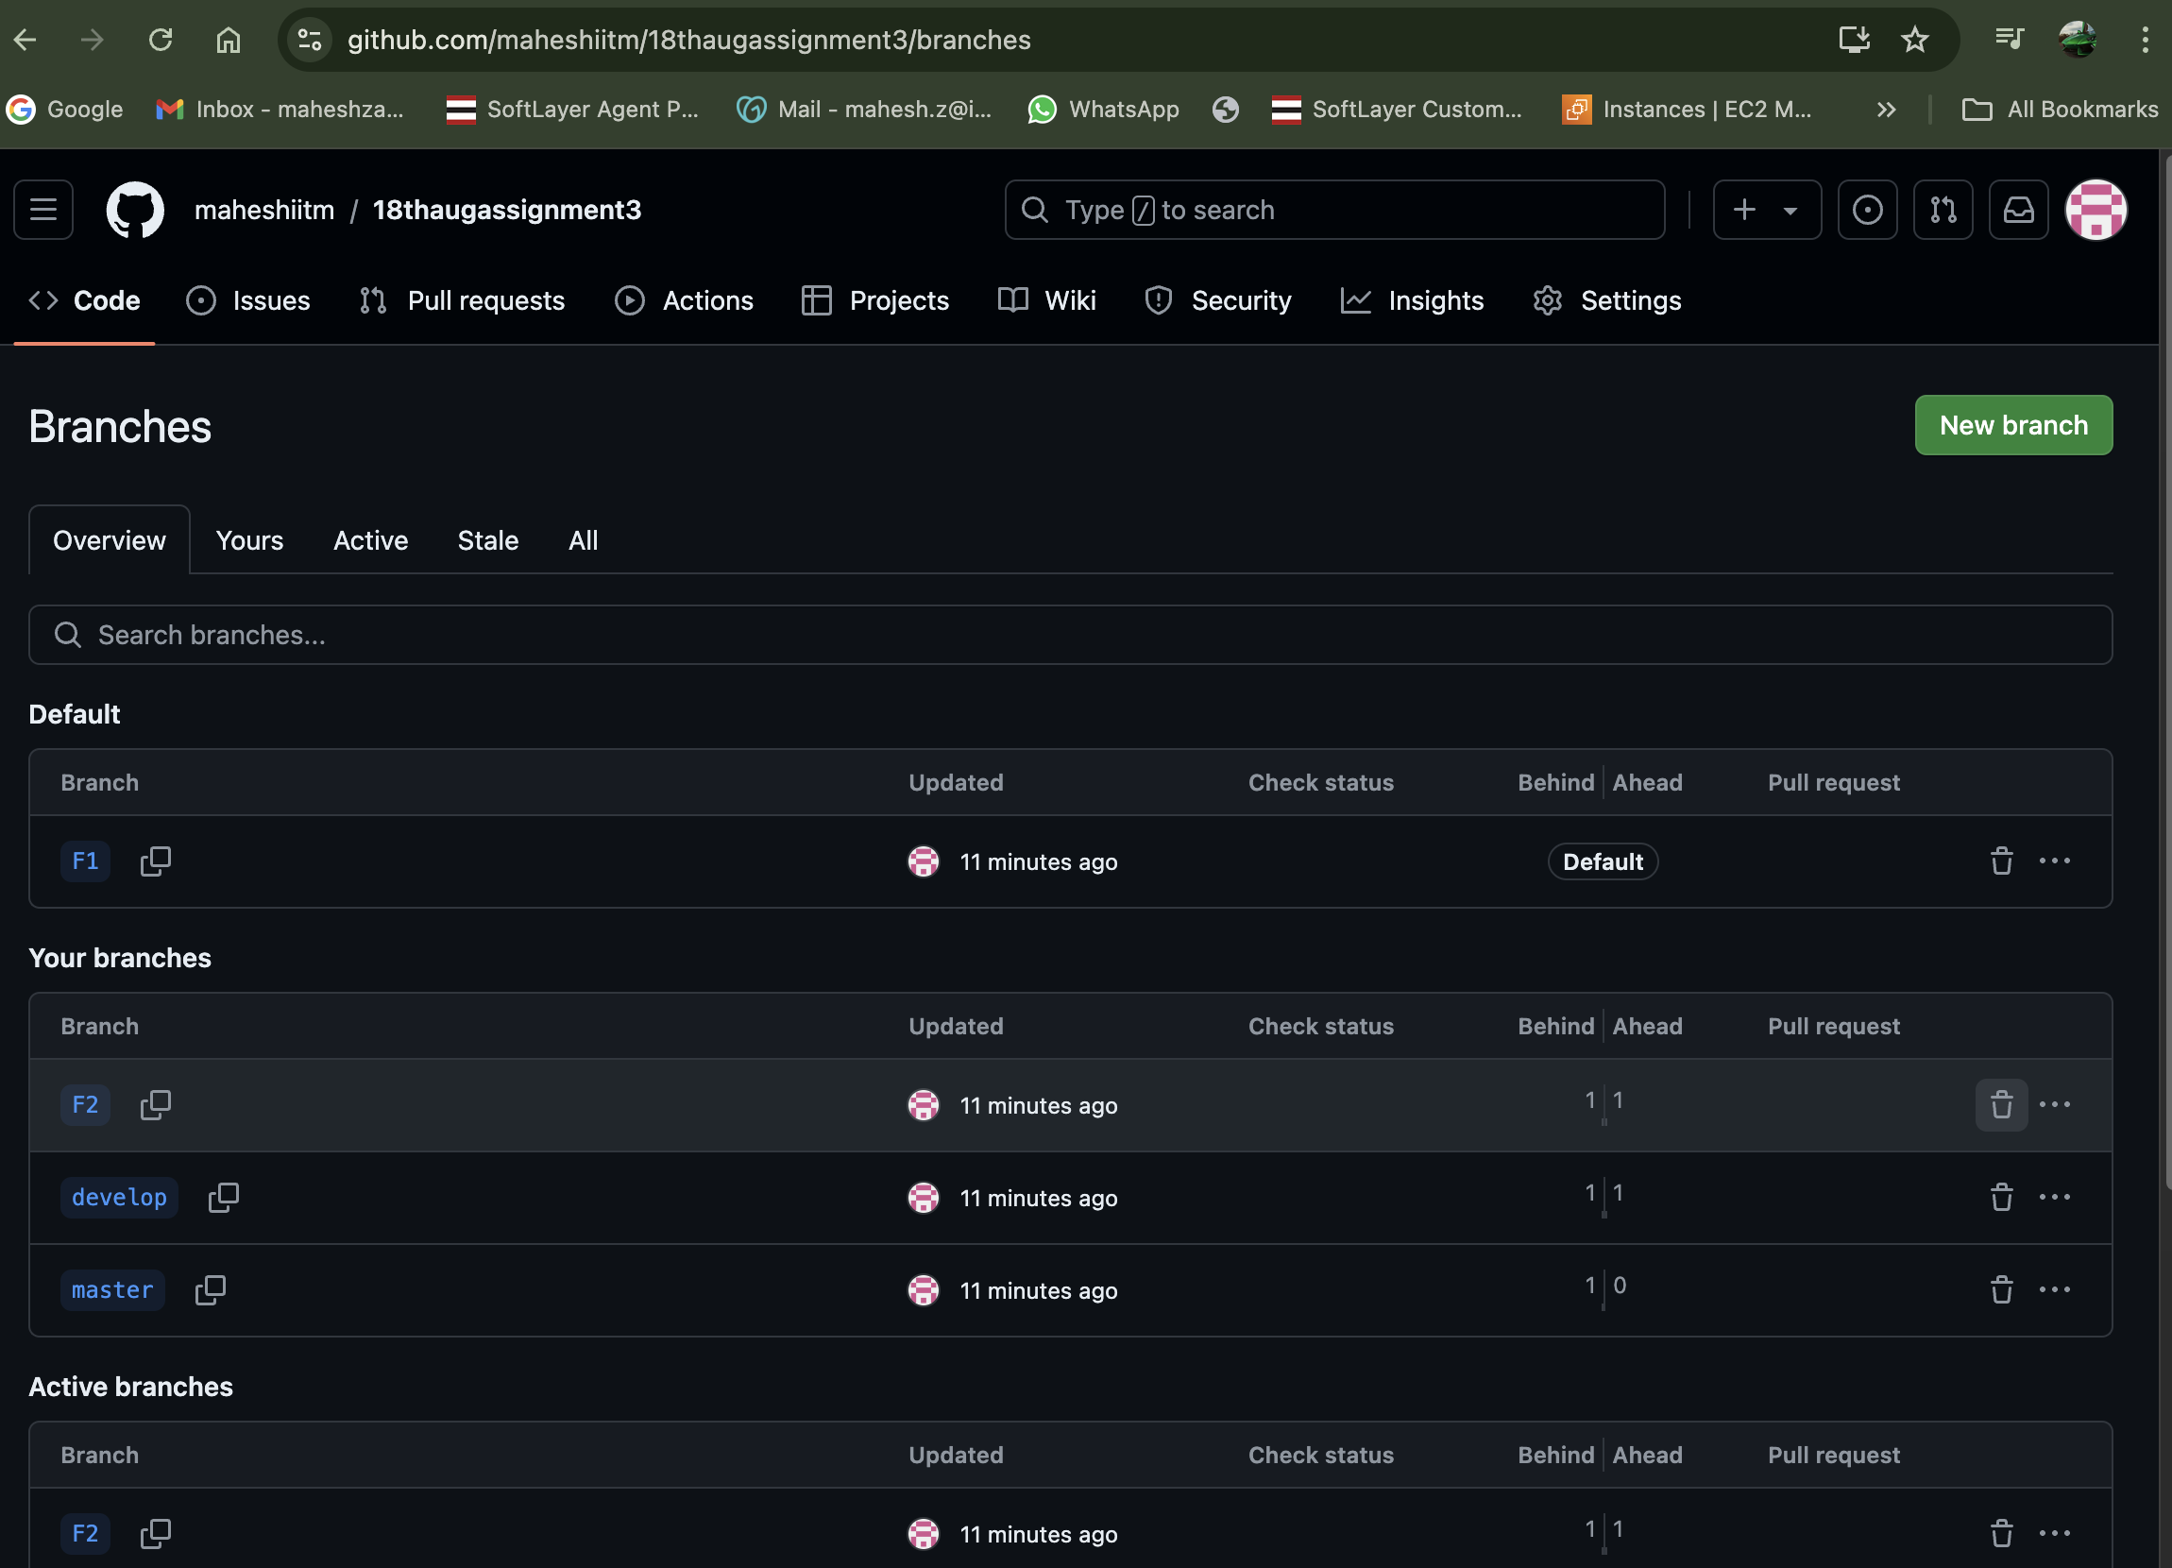

**F2 Branch delete now**

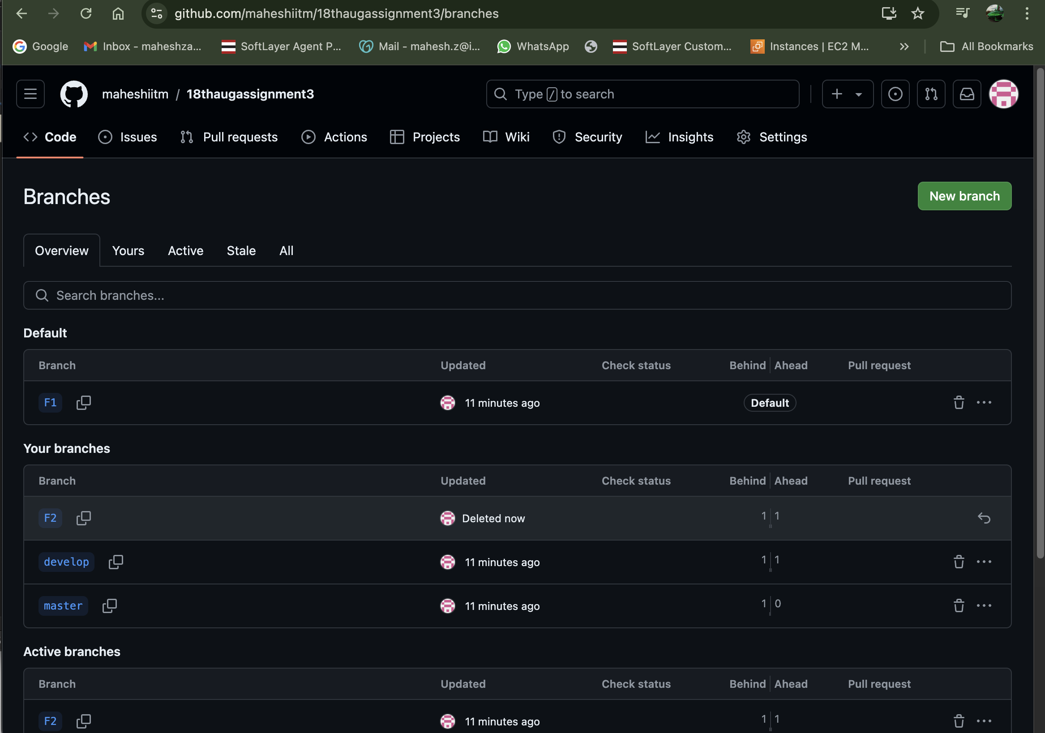

**Commads use in Assignment 3**

294 mkdir Assignment3

295 cd Assignment3

296 git init

297 nano main.txt

298 git add .

299 git commit -m "mai. text file is added in the master branch"

300 cd assignment1/

301 git branch

302 git remote -v

303 git remote add origin https://github.com/maheshiitm/18thaugassignment1.git

304 git push origin master

305 history

306 cd assignment3

307 ls

308 cd assignment3

309 cd Assignment3

310 ls

311 git branch

312 git branch develop

313 git branch F1

314 git branch F2

315 git branch

316 git checkout devlop

317 git checkout develop

318 git branch

319 touch develop.txt

320 ls

321 git add .

322 git commit -m "added the devlop text file"

323 git branch

324 git status

325 git checkout f1

326 git branch

327 git switch F1

328 git branch

329 touch F1.txt

330 git add .

331 git commit -m "added all the files"

332 git status

333 git checkout F2

334 git branch

335 touch f2.txt

336 git add .

337 git commit -m "added the f2 text file"

338 git status

339 ls

340 ssh-keygen

341 ls

342 cd .ssh/

343 cd

344 cd

345 ssh-keygen

346 ls

347 cd .ssh/

348 ls

349 cat id_ed25519.pub

350 cat id_ed25519

351 sudo apt update update

352 sudo apt update

353 cd

354 cd Assignment3

355 ls

356 git remote-v

357 git remote add origin git@github.com:maheshiitm/18thaugassignment3.git

358 git push origin --all

359 history

360 git branch

361 git switch master

362 git branch F2 -d

363 git branch -D F2

364 history

ubuntu@ip-172-31-85-51:~$